Information for using the XBOX 360 chatpad with arduino.

<http://cliffle.com/project/chatpad/arduino/>

The Pinout:

<http://cliffle.com/project/chatpad/pinout/>

## **Internal connector pins**

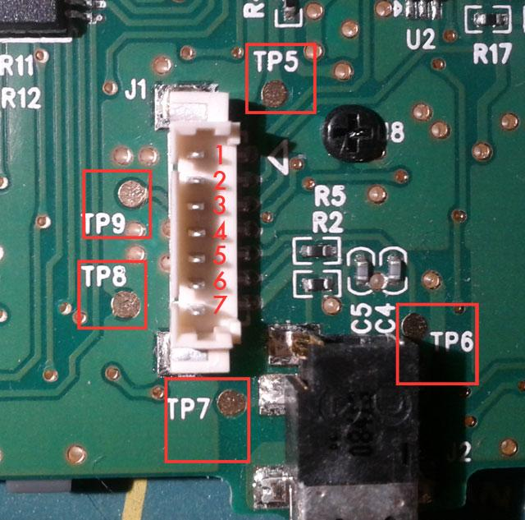

Chatpad internal connector with pins labeled

## **External connector pins**

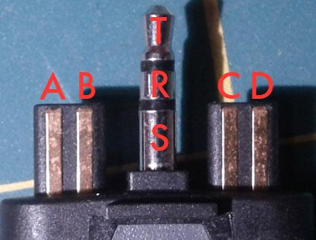

Chatpad external connector with pins labeled

## **Signals**

| ***Int. Pin*** | ***Ext. Pin*** | ***TP*** | ***Signal*** |
| --- | --- | --- | --- |
| 1 | A | 5 | +3.3V |
| 2 | B | - | RX IN |
| 3 | C | 9 | TX OUT |
| 4 | D | 8 | Ground |
| 5 | Tip | 6 | Tip (Audio) |
| 6 | Ring | 7 | Ring (Audio) |
| 7 | Shield | - | Shield (Audio) |